**Metropolitan State University**

**ICS 311- 50 Database Management Systems**

**Summer 2023**

**Term Project – Step 2**

**Due Date: 7/3/2023**

**Name: Abdullahi Farah**

**Points: 60**

In this step of the project you are required to provide the conceptual design for your application database and draw the Entity-Relationship Diagram (ERD). The purpose of the ERD is to record and model the business rules that need to be supported by your application as stated in your project proposal.

**Part 1: Entity-Relationship Diagram (ERD):**

Draw the Entity-Relationship Diagram (ERD) for your application to show the entities and relationships. Make sure to clearly show the following:

1- All entities (i.e., objects) that are needed to implement your application

2- Each entity must be identified by a primary key and described by a set of attributes.

3- List clearly all relationships between entities (Business Rules). For example, the relationship between Customer and Invoice entities is described as “Each customer can have more than one invoice, however, an invoice can belong to only one customer.

4- Relationship cardinalities for all relationships in your ERD (1-to-1, 1-to-M, or M-to-M).

Convert the ERD that you designed in Part 1 into the corresponding relational schema. The relational schema should include the following:

1. Table names
2. Attribute names and data types
3. Primary keys
4. Foreign keys

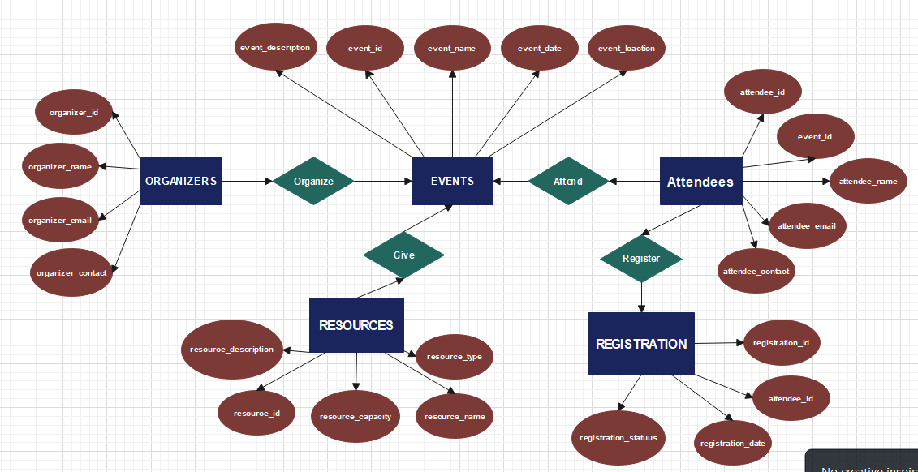

Organizers (

organizer_id (Primary Key, INT),

organizer_name (VARCHAR(255)),

organizer_email (VARCHAR(255)),

organizer_contact (VARCHAR(255))

)

Events (

event_id (Primary Key, INT),

event_name (VARCHAR(255)),

event_date (DATE),

event_location (VARCHAR(255)),

event_description (VARCHAR(255)),

)

Attendees (

attendee_id (Primary Key, INT),

attendee_name (VARCHAR(255)),

attendee_email (VARCHAR(255)),

attendee_contact (VARCHAR(255)),

event_id (Foreign Key, INT, References Events(event_id))

)

Resources (

resource_id (Primary Key, INT),

resource_name (VARCHAR(255)),

resource_type (VARCHAR(255)),

resource_capacity (INT),

resource_description (VARCHAR(255)),

)

Registrations (

registration_id (Primary Key, INT),

attendee_id (Foreign Key, INT, References Attendees(attendee_id)),

registration_date (DATE),

registration_status (VARCHAR(255)),

)

**Relationships:**

1. An organizer can organize multiple events, but an event is organized by only one organizer (1-to-M relationship between Organizers and Events).
2. An event can have multiple attendees, and an attendee can attend multiple events (M-to-M relationship between Attendees and Events).
3. Each attendee can make multiple registrations, and each registration is made by only one attendee (1-to-M relationship between Attendees and Registrations).
4. Each event can have multiple resources, and a resource can be associated with multiple events (M-to-M relationship between Resources and Events).

**Part2**

Implement your database on MySQL. Your implementation should include the following:

1- Create all the tables that you specified in your relational schema (Part 1). Make sure to include primary keys and foreign keys.

2- Populate all tables with data of your choice. Make sure that each table includes at least 10 rows.

**What to submit:**

1. Answers for Part1
2. The following for Part2

‘.sql’ scripts that include:

SQL statements to create the tables (from Part 2 above).

SQL statements to populate tables with data (from Part 2 above).

Note that you need to include all the required SQL statements in file. This could be a Word Doc. or a text file that ends in “.sql”. **Make sure to test your file before you submit it.**